PASTE FILL WITH RECLAIMED TAILINGS: A SUSTAINABLE SOLUTION FOR RISK MANAGEMENT

(Mining Operations & Asset Management – Ancillary Services)

**Hector Orrego Moya1 & Anthony G (Tony) Grice2**

1 Author: AMC Mining Consultants (Canada) Ltd, Vancouver, BC, Canada (horrego@amcconsultants.com, +1 604 669-0044)

2 Coauthor 1: AMC Mining Consultants (Canada), Vancouver, BC, Canada (tgrice@amcconsultants.com, +1 604 669-0044)

____________________________________________________________________________________

**SUMMARY**

Tailings management and the mitigation of its associated risks are an imperative for modern mining operations. This paper presents a proven and cost-effective solution: the use of tailings recovered from existing storage facilities to produce paste backfill. This methodology significantly reduces capital expenditures compared to conventional plants, thereby democratizing access to the benefits of paste backfill and expanding its application to closure and remediation projects. The success of the technology, however, hinges on rigorous technical control of the feed material, which includes its characterization, management of moisture variability, and pre-conditioning. It is concluded that this approach offers significant potential for mining in the Andean region, provided that local logistical and climatic challenges are addressed.

**1. Introduction**

The global mining industry faces increasing pressure to improve its tailings management, driven by stricter standards such as the Global Industry Standard on Tailings Management (GISTM) and greater socio-environmental awareness. While paste backfill is recognized as a technically superior solution for enhancing underground geotechnical stability and reducing surface environmental footprints, its adoption has historically been limited by the high capital costs of the paste plant, filters, dewatering components and pumping included.

This paper presents a proven alternative that overcomes this economic barrier: the use of recovered ("harvested") tailings from existing deposits. By eliminating the need for complex filtering or thickening systems and instead utilizing modular mixing plants, this methodology significantly reduces the initial investment. This not only makes paste backfill viable for a greater number of operations but also expands its applicability beyond underground mine backfilling, opening new and profitable avenues for the remediation of environmental liabilities and the progressive closure of sites.

**2. Objectives**

The primary objective of this paper is to demonstrate the technical viability and cost-effectiveness of paste backfill systems that utilize recovered tailings as a safe and sustainable waste management solution.

The specific objectives are:

* To evaluate the technical and economic advantages of this approach compared to conventional paste plants and other tailings management technologies.
* To define the critical operating parameters and quality control protocols essential for the feed material, from initial characterization to the rheology of the final paste.
* To share lessons learned from international case studies, highlighting the benefits achieved and the operational challenges overcome in implementing this technology.
* To analyze the application potential and implementation challenges of this technology within the context of the Andean mining, considering its unique logistical, geographical, and climatic characteristics.

**3. Methodology and case Analysis**

This study is based on a methodology that combines the geotechnical characterization of the material with a detailed analysis of case studies, from which critical operating parameters and lessons learned are extracted.

**3.1 General – Mine Backfill**

Mine backfill is an integral component of the mining cycle, consisting of the placement of materials such as waste rock, sand, or process tailings—often combined with a binding agent—into the underground voids created by mineral extraction. Its primary purposes are to re-establish rock mass support to control subsidence and seismicity, create safe working faces for the extraction of adjacent stopes or pillars, enable higher reserve recovery, and sustainably manage waste generated by the process plant. The design of the backfill system must align with the mining method, deposit geomechanics, mining sequence, and waste management strategy. The early optimization of its key parameters, such as the Unconfined Compressive Strength, which is typically designed for values between 0.5 and 5 MPa, directly impacts the safety, productivity, and economics of the project. Furthermore, by reducing the footprint of surface tailings storage facilities, mine backfill strengthens the social license to operate.

**3.2 Paste Backfill: What It Is and Its Advantages**

Paste Fill (PF) is a high-density, non-segregating slurry made from tailings, water, and a binder (such as Portland cement or metallurgical slag). Unlike simple fluids with constant viscosity, paste fill behaves as a non-Newtonian fluid (Kuganathan & Grice, 2007). It's typically modeled as a Bingham plastic, meaning it only begins to flow once a certain minimum force, known as the yield stress, is applied. This yield stress commonly ranges from 100 to 1,000 Pa, and it is this property that allows the paste to hold its shape and not segregate once deposited. Unlike hydraulic fill, which is a high-water content slurry where fines are removed to promote drainage and segregation occurs during deposition, PF utilizes the full tailings stream.

The main advantages of paste fill are significant. It exhibits **minimal water bleed**, which liberates little to no drainage water, thereby eliminating the need to manage large volumes of underground water and reducing the load on the mine dewatering system. The material develops **consistent and homogeneous early strength**, allowing for shorter filling cycles and accelerating the recovery of adjacent pillars. Paste fill can incorporate the **entire tailings stream**, which maximizes tailings utilization and reduces and, in some cases, eliminates the need for surface tailings storage facilities. The lower segregation and more efficient use of the binding agent can also lead to **reduced operating costs** compared to other backfill methods. Finally, the system offers **distribution flexibility**, as the paste can be pumped at high pressure or transported by gravity, depending on its rheology and the mine's layout. Paste production plants can be configured to operate in-line with the process plant using fresh tailings, or as "harvested tailings" systems that process material excavated from historical tailings deposits.

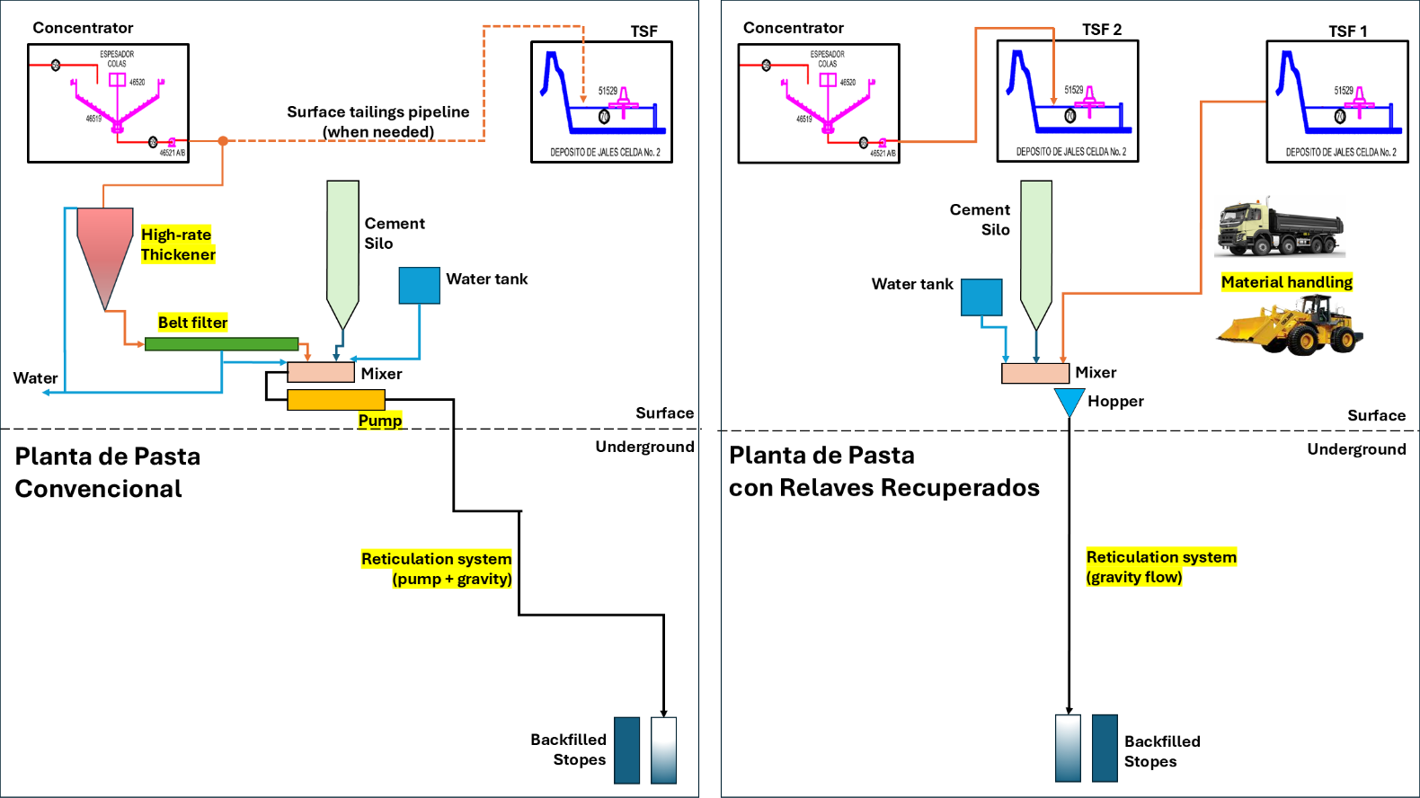

Figure 1, Comparison of Paste Fill Layouts: Conventional Tailings vs. Recovered Tailings

Figure1 illustrates the significant process simplification offered by the recovered tailings system (right). In contrast to the conventional layout (left), the recovered tailings approach eliminates the capital-intensive dewatering circuit, requiring no high-rate thickener, filter plant, or intermediate agitated storage tanks. The modularity of the recovered tailings plant allows for strategic placement close to the point of use. This often enables paste distribution entirely by gravity, thereby avoiding the high capital and operating costs associated with pumping systems.

**3.2.1 Tailings Characterization**

The viability and performance of a paste backfill system depend on a thorough characterization of its components (Potvin, 2005). The critical parameters governing the paste's behavior are the particle size distribution (PSD) of the tailings, the particle density, and the rheology of the mixture.

**3.2.1.1 Particle Size Distribution (PSD)**

The PSD is fundamental to the stability and rheology of the paste. Unlike hydraulic fill, which is deslimed to keep the fines fraction (< 10 µm) below 10% by weight to maximize permeability (> 50 mm/h), paste requires a minimum fines content to be stable. Generally, the target is for at least 15% by weight of the particles to be smaller than 20 µm. This fine fraction is crucial for retaining water, preventing particle segregation during transport and deposition, and acting as a lubricant that improves pumpability. As observed in one of the case studies, historical tailings with a finer PSD demand more water to achieve a given fluidity, which can negatively impact the final strength if the binder dosage is not adjusted accordingly.

**3.2.1.2 Density**

The density of the solids (Specific Gravity, SG) is a fundamental parameter for calculating pulp density and for quality control. Quartz and silicate tailings typically have an SG of 2.7 to 2.8 t/m³, whereas materials with higher sulfide or iron mineral content can exceed this value. For instance, at one Ghanaian gold mine, dumped tailings samples averaged 2.78–2.79 t/m³, with individual values up to 2.93 t/m³.

**3.2.1.3 Rheology**

Rheology describes the flow and deformation of the paste. The key parameters are yield stress and plastic viscosity. Yield stress is the minimum stress required to initiate flow and is a direct indicator of the paste's ability to keep particles in suspension. A common objective is to achieve yield stresses of 150 to 250 Pa, which ensures a stable material that does not segregate but remains pumpable. The slump test is the most common field method for indirectly controlling rheology. A typical slump for gravity-transported paste is 200 to 250 mm (8 to 10 inches).

**3.2.1.4 Main Controls**

**3.2.1.4.1 Moisture Control in Paste Backfill**

Precise control of the solid-water ratio is the most critical operating parameter. The paste is prepared by remixing the filtered tailings cake to achieve a target density, which usually corresponds to a solids content of approximately 70% to 80% by weight. Small variations in moisture content can cause large changes in rheology. An excess of water reduces yield stress, causing segregation and bleed, while a lack of water can increase yield stress to the point of blocking pipelines. Operators monitor density in-line (with nuclear densometers and magnetic flow meters) and use slump tests as a rapid quality control check to ensure product consistency.

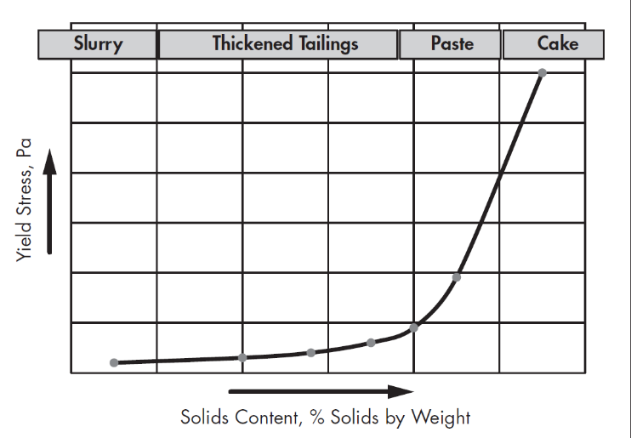

Figure 2, representation of the continuous change in material properties as a slurry's density increases toward that of a filter cake  
Source: (Jewell & Fourie, 2015)

Figure 2 illustrates the continuous and non-linear transformation of tailings properties as water is removed and the solids content by weight increases. This relationship, often termed the "tailings continuum," is fundamental to understanding and designing any paste fill system. At lower solids concentrations, the material behaves as a conventional slurry or thickened tailings, exhibiting low yield stress. As the solids content increases, there is a distinct and exponential rise in yield stress, marking the transition into a "paste." A true paste is a non-segregating mixture that behaves as a homogeneous fluid when pumped but has sufficient internal shear strength to prevent particle settling when at rest. Further dewatering produces a filter cake, a damp geotechnical solid with high shear strength that is no longer pumpable and must be handled by mechanical equipment like conveyors or trucks. The objective of a paste backfill system is to operate within the steep part of this curve, precisely controlling the density to produce a material that is flowable yet stable upon placement.

**3.2.1.4.2 Particle Size Control in Paste Backfill**

Maintaining a consistent particle size distribution is essential for system predictability. Variations in grinding or in the material source (e.g., when mixing tailings from different zones of a historical deposit) can alter the Particle Size Distribution (PSD). This directly affects water demand and, consequently, the rheology and final strength. When using recovered tailings, it is common to implement pre-conditioning by screening or adding other materials (such as sand, in the case of Junction & Lanfranchi mines (Li et al., 2002) to adjust the PSD and ensure the feed to the paste plant remains within design specifications.

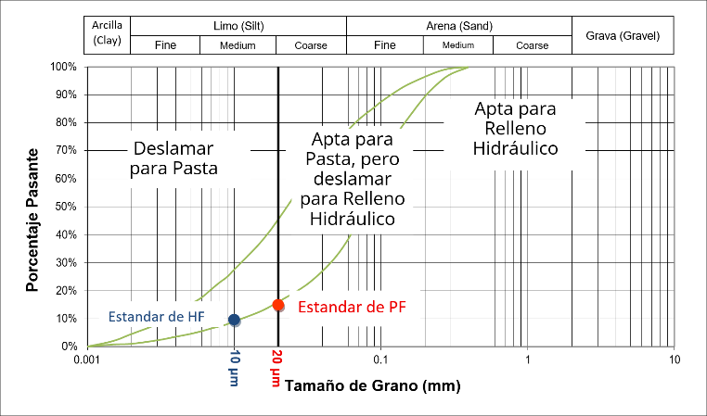

Figure 3, Particle Size Distribution

The figure 3 illustrates the critical role of PSD in determining the suitability of tailings for different backfill methods. The key differentiator is the percentage of fine particles (clays and silts), typically defined as the fraction passing a specific sieve size, such as 20 micrometers, cannot be measured by traditional sieving and is instead determined using methods such as laser diffraction analysis. The suitability of a material for paste fill is fundamentally dependent on having a sufficient quantity of these fines. As shown, a common industry benchmark requires a minimum of 15% of particles to be smaller than 20 µm. This fine fraction is essential for retaining water within the mix, preventing segregation (bleeding), and generating the required rheological properties (yield stress) for a stable, non-segregating paste.

**3.2.1.4.3 Determine Fill Strength characteristics**

The determination of required backfill strength is fundamental to ensuring geomechanical stability and operational cost-effectiveness, beginning with a structured laboratory testing program to characterize strength gain as a function of binder content, mix density, and curing time. Standard practice involves performing uniaxial compression tests on cylindrical samples, typically in accordance with ASTM C31/31M, at specified curing intervals such as 7, 28, and 56 days. The data from this program are analyzed to develop a family of performance curves that correlate unconfined compressive strength (UCS) with both binder dosage and curing time (see Figure 4). These performance curves are then used to select the optimal mix in an economic trade-off, identifying the leanest possible formulation that achieves the target strength required by the geomechanical design criteria for a given stope exposure and turnover cycle, thereby minimizing binder costs, which represent the largest component of operating expenses.

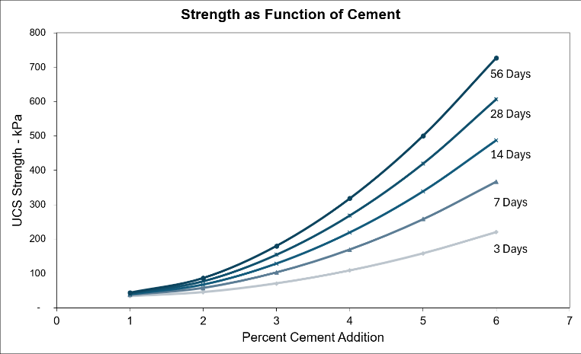

Figure 4, Backfill Strength as a Function of Binder Content and Curing Time

**3.3 Case Studies of Key Operations**

To illustrate the application and challenges of this technology, seven mining operations were analyzed. These cases, although not all use recovered tailings, employ equipment and face material characterization challenges that are directly relevant to the subject of this study.

**3.3.1. Junction Mine, Australia**

The Junction mine paste plant is a foundational case study in the use of recovered tailings (Li et al., 2002), using dry tailings harvested from old dams and transported 11 km to the plant as its raw material. The feed material was optimized by adding approximately 20% dune sand to improve the paste rheology (see Figure 5). This system represented a significant shift from the previous hydraulic fill plant, enabling the mine to adopt top-down mining methods without leaving remnant pillars, which greatly increased flexibility and resource recovery.

Figure 5 Reclaimed tailings area

Material characterization identified a key operational challenge: the presence of cohesive clay lumps in the recovered tailings, a product of natural segregation during deposition. Extensive rheological studies were conducted to define the properties of the tailings-sand mixtures, establishing a target yield stress of 250 Pa for optimal flow. However, the clay lumps did not fully break down in the process, leading to variations in paste consistency and affecting the reliability of the feed to the mixer.



Figure 6, Paste Fill prepared with lumps obstructing receiving hopper

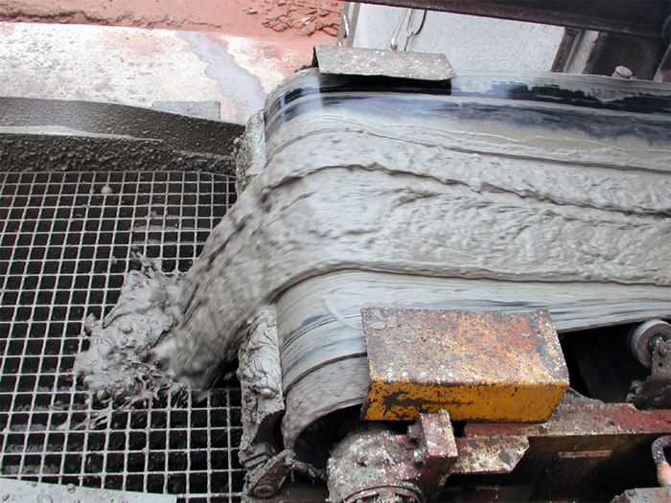

Figure 7, Paste fill showing optimal gradation of mix

For paste preparation, a continuous Aran-type mixing plant with a capacity of 130 m³/h was implemented (see Figure 8). Key equipment included a vibrating screen on the mixer's discharge hopper, designed to capture oversized material. This screen frequently became clogged with clay lumps, requiring constant manual intervention and causing process interruptions (see Figures 6 and 7). Solutions evaluated to address this problem, which was directly linked to the nature of the recovered tailings, included pre-screening the feed material and increasing the screen aperture, demonstrating the need to adapt processing equipment to the specific characteristics of the harvested material.

Figure 8, Pastefill Modular Plant -fit in 04 C-cans

**3.3.2. Kencana Mine, Indonesia**

The Kencana mine is an analogous case that, while not using tailings, demonstrates the flexibility of mobile plant technology for processing unconventional materials (Grice et al., 2009). The system is fed with a locally sourced volcanic tuff, a material that shares characteristics with recovered tailings, such as high natural moisture content and a tendency to form agglomerates. This innovative approach eliminates the need for a conventional filtering plant, aligning with the low CAPEX objective of harvested tailings systems.

Material characterization was crucial for the operation's success. It was identified that the Kao tuff was a reactive pozzolan and that its lumps were friable, which allowed the screening specification to be relaxed from <5 mm to <25 mm, improving operational efficiency without compromising paste quality. It is noteworthy that during the design phase, the recovery of tailings from the existing Tailings Storage Facility (TSF) was evaluated. However, this analysis concluded that the tailings were unsuitable for harvesting due to their high degree of saturation—a key lesson on the importance of geotechnical characterization of the deposit as a prerequisite.

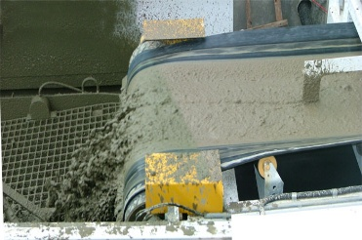

Figure 9, Paste Production and Placement- Hopper

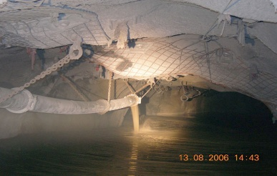

Figure 10, Paste Production and Placement- into a stope

The preparation process is carried out in a modular Aran DuoMix Plant (see Figures 11 and 12) with a capacity of 150 m³/h, which mixes the screened tuff with cement and water. The main operational challenge is not managing clays, but controlling the moisture of the feed material, which is exacerbated by the tropical climate. This risk is effectively managed by stockpiling the tuff under protective covers, ensuring a feed with controlled moisture content to the mixer. Kencana demonstrates that with proper controls, mobile plants can reliably handle a variety of wet and agglomerated feed materials.

Figure 11, modular Paste Plant

Figure 12, modular Paste Plant-Feeding Tailings

**3.3.3. Niquel Mines Lanfranchi, Australia**

The Lanfranchi mine is a relevant example that applies circular economy principles, analogous to recovered tailings systems, by using other mining waste streams to produce Cemented Aggregate Fill (CAF). Instead of tailings, this low-CAPEX system uses development waste rock or heap leach material (Figure 13) as the primary aggregate, crushed to a size of less than 40 mm (Grice et al., 2007).

Material characterization and optimization focused on improving the particle size distribution to reduce the consumption of cement, the main operating cost. This optimization was effectively achieved by incorporating up to 20% dune sand into the crushed aggregate. This addition of dune sand directly addressed the interstitial voids between larger aggregate particles, creating a denser mixture that closely approximates an ideal grading curve. By minimizing the mixture's porosity, the volume of binding agent required to fill these voids and bind the particles was substantially reduced, leading to significant cost savings. The preparation equipment consisted of a conventional concrete batch mixer with a capacity of 50 dry tonnes per hour, which fed a vertical borehole (pipe) for underground delivery. Significantly, the engineering study also considered a specialized mobile mixing plant as a technologically viable alternative. This fact underscores the versatility of modular mixing plants, demonstrating that the same type of equipment used for recovered tailings can be effectively adapted to process a range of waste materials and produce different types of cemented backfill.

Figure 13 Heap Leach Aggregate

Figure 14, Cemented Aggregate Fill (CAF) Production Systems at Lanfranchi Nickel Mine - OLD

Figure 15, Cemented Aggregate Fill (CAF) Production Systems at Lanfranchi Nickel Mine - NEW

The images 14 and 15 illustrate the equipment used and considered for producing CAF at the Lanfranchi mine, a key example of applying circular economy principles by converting mining waste into a resource.

Figure 14 shows the conventional concrete batching plant that was used at Lanfranchi. This system was fed with crushed waste rock and dune sand, which was added to optimize the particle size distribution and minimize the consumption of cement binder, the primary operating cost.

Figure 15 shows a specialized mobile mixing plant. This type of modular plant was identified during the engineering study as a technologically viable alternative for producing the CAF. It proves that the same type of equipment central to the recovered tailings model can be effectively repurposed to process entirely different waste streams, such as waste rock, to produce various types of engineered backfill.

**3.3.4. George Fisher Mine (GFM), Australia**

The George Fisher Mine (GFM) is a benchmark in the implementation of Harvested Tailings Paste Fill Systems (Kuganathan, 2011). These systems, characterized by their lower capital cost compared to conventional paste plants that operate in-line with the concentrator, have gained popularity in the industry. GFM effectively illustrates the challenges and solutions inherent in this approach.

Figure 16, Tailings Recovery

Figure 17, Twin-axle Paddle Mixer

The operation uses a twin-axle paddle mixer Aran-type plant (Figure 17), common equipment for this type of application. In line with the philosophy of recovered tailings systems, the main focus at GFM is on the preparation and quality control of the feed material to ensure a consistent final product. The raw material is extracted from a 20-year-old tailings deposit located 22 km from the mine (Figure 16). The recovery and transport process generates significant challenges, such as the formation of tailings agglomerates and contamination with rock fragments (Figure 18).

Figure 18, Pre-conditioning Circuit - Tailings lump size

To mitigate these problems, GFM implemented a pre-conditioning circuit, which includes screening and impact crushing. This step is critical and aligns with standard practice for recovered tailings systems, where controlling the maximum particle size is essential for operational success (Figure 19).

The panoramic view in Figures 20 and 21 shows the overall layout of the surface operation, including the stockpiles of raw and pre-conditioned tailings. The scale of the operation highlights the logistical effort required to manage and prepare the feed material before it enters the paste plant.

Figure 19, Pre-condittioning of harvestd tailings at GFM

A notable aspect of GFM's operation is the management of paste rheology. The system deliberately produces a paste with a high slump of 240-260 mm. Far from being a defect, this high fluidity is an engineered solution designed to overcome a constraint in the plant. It allows the paste to flow smoothly through a safety grizzly in the mixer hopper, which prevents residual agglomerates from blocking the underground distribution system. With a 4% cement addition, this backfill has proven to be fully competent upon exposure in secondary stopes.

In summary, the experience at GFM, which migrated from a Cemented Sand and Aggregate Fill (CSAF) to a harvested tailings paste system in 2005, demonstrates how rigorous attention to material preparation and intelligent adaptation of paste rheology are key to success. The case validates the harvested tailings system model as a viable and robust backfill solution, even when faced with long-distance logistics and complex feed material.

Figure 20, Panoramic View of the Feed Preparation Area

Figure 21 Overview of Harvested tailings Pad and Modular Paste Fill Plant

**3.3.5. Birla Nifty Mine, Australia**

The Birla Nifty operation serves as an analogous case that illustrates the flexibility of modular mixing plants, the core equipment in most recovered tailings systems (Grice et al., 2009). Although the system described is for hydraulic sand fill, it uses a dual agitator mixer plant from Ready-Mix, one of the technology providers for preparing paste with harvested tailings.

The feed material preparation, although involving sand, follows a principle similar to that for recovered tailings: the need for prior quality control to ensure system operability. The main characterization consists of screening the sand to remove all oversized and organic material, such as roots and plant debris. This step is analogous to the crushing and screening of recovered tailings to eliminate lumps and prevent blockages in the transport system. The processing equipment, a Ready-Mix batch plant, was adapted to produce the continuous flow required for transporting a sand slurry, which is prone to sedimentation. The operating procedure requires the coordinated management of the two mixers to maintain a constant flow above 100 m³/h, ensuring the pipeline velocity remains above the critical settling velocity of 2 m/s. This case demonstrates how the same modular equipment can be adapted, through specific operating procedures, to handle different types of materials with distinct hydraulic behaviors.

Pictures 22 and 23 show the layout of the Ready-Mix batch plant used to produce hydraulic sand fill. The setup includes feed hoppers, conveyors, and the dual agitator mixers. The key operational challenge here was adapting this batch-style equipment to produce a continuous flow. This was necessary to maintain a pipeline velocity above the critical settling velocity for the sand slurry, preventing blockages.

Figure 22, Hydraulic Sand Fill Production Using a Modular Batch Plant at Birla Nifty Mine

Figure 23, Plant Overview

Picture 24 shows the final product being discharged from the mixer. The fluid, slurry-like consistency is evident. This contrasts sharply with the thick, non-segregating nature of a paste. The ability to produce such different products from similar modular plants highlights the equipment's adaptability. The case underscores that with the correct operating procedures—such as coordinated mixer management and rigorous pre-screening of feed material to remove organics—this technology can be successfully applied across a wide range of backfill duties.

Figure 24, Hydraulic Fill Discharge into Hopper (Gravity Flow)

**3.3.6. Mina Obuasi, Ghana**

To resolve a significant production bottleneck, the Obuasi Mine strategically transitioned from a restrictive hydraulic fill system to a more efficient paste backfill operation. The previous hydraulic fill method limited production due to its reliance on only the coarse fraction of tailings and the long stope dewatering cycles required. By adopting paste fill, which utilizes the full tailings stream and allows for continuous placement, the mine eliminated these constraints, optimizing production cycles and justifying the higher capital investment through increased output.

A key part of the project involved assessing the feasibility of using recovered historical tailings and other local materials to accelerate the mine's restart. This investigation highlighted the critical importance of material characterization and binder selection.

* The recovered tailings were significantly finer than fresh tailings, demanding more water to achieve the target slump, which resulted in low pulp density and poor strength when using conventional Portland cement. To reach the 300 kPa design strength, uneconomical binder dosages of up to 8% were required.
* An evaluation of local soil from the Sansu pit found it unsuitable for preparing competent backfill due to its mineralogy, which was high in kaolin and goethite, as these minerals significantly increase water demand and impair binder performance.
* The viability of the recovered tailings was ultimately confirmed when an alternative slag-based binder was tested, which increased the 28-day strength six-fold compared to conventional cement at the same 4% dosage, transforming a marginal material into a robust and economic backfill solution.

**3.3.7 Harvested Tailings Paste Fill in the Andean Region**

The harvested tailings model is particularly well-suited to the challenging Andean mining environment. The region's rugged and water-charged terrain often limits the viability of surface dams and drives a strategic interest in maximizing underground tailings disposal. The Mina Ares operation is a representative case study, where a harvested tailings system was successfully implemented under these exact conditions, bypassing capital-intensive filtration by using feed from older, naturally low-moisture impoundments.

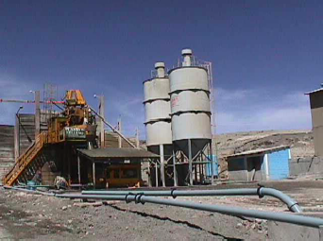

Figure 25, Stetter CP30 Paste Batching Plant.

Figure 25 shows the central Paste Fill Batching Plant. The two silos are for storing cement, which is the primary binding agent. In this plant, the solid components are mixed with heated water before being discharged into a piston pump. The pipeline visible in the foreground is the beginning of the high-pressure reticulation system that transports the final paste product underground to the stopes.

Operational success at Ares was achieved through rigorous control of the feed material's particle size distribution (Figures 26 and 27). Early campaigns established that maintaining a sufficient fines content (≥15% sub-20 µm particles) was critical for flowability, which enabled a significant reduction in binder consumption and cut the overall backfill operating cost in half (Paniagua, 2005). To further optimize the mix, the mine now blends screened volcanic tuff with the harvested tailings (Grice et al., 2007). This PSD tailoring enhances both pumpability and final cured strength, a practice that underscores the necessity of stringent quality control.

Figure 26, Material Handling and Plant Feed

Figure 27, Raw Material Sourcing

**4. Presentation and Discussion of Results**

Operational data from over two decades establishes backfill with recovered tailings as a mature, robust technology. This approach strategically trades the high capital cost of a fixed dewatering plant for the operating logistics of material handling. The following analysis details the resulting economic advantages and the essential operational disciplines required for success.

**4.1 Economic Analysis**

**4.1.1 Baseline Case: Lifecycle Cost and Risk of the Conventional Tailings Storage Facility (TSF) Alternative**

The baseline alternative of a conventional slurry TSF, representing the status quo, carries substantial and continuous lifecycle costs and liabilities. Lifecycle capital expenditures for these facilities, which include both the large initial starter embankment and subsequent raises, are benchmarked in a range of $5 to $7 USD per tonne of stored tailings in mid-size operations in the Andean region. While ongoing operational expenditures can be lower than dewatered alternatives—ranging from $0.5 to $1.5 USD per dry tonne of tailings —the overall cost profile is highly sensitive to project scale (Carneiro & Fourie, 2018). This approach is also land-intensive, requiring a larger surface footprint than other methods for the same storage capacity. Critically, these direct expenditures do not account for the final liability of facility reclamation, a process often delayed by a required multi-year drying period before work can commence, followed by the significant costs of closure and long-term monitoring.

The financial liabilities of a conventional TSF are magnified by its inherent engineering risks. The primary technical concern with conventional impoundments is their inherent stability risk, with common failure modes including geotechnical instability and water mismanagement. The historical annual failure probability for these facilities is estimated to be between 1 in 700 and 1 in 1750, a rate an order of magnitude higher than the 1 in 10,000 benchmark for engineered water dams (Davies, & Rice, 2001). The consequence of such a failure is catastrophic, with recent industry events demonstrating financial and environmental liabilities in the tens of billions of dollars, representing an existential threat to any mining operator. This combination of a statistically high failure rate and the immense consequence of failure categorizes the "business as usual" conventional slurry alternative as a high-risk engineering and financial strategy.

**4.1.2 Economic Evaluation of Paste Fill Alternatives**

The selection between a conventional and a harvested tailings paste plant is a trade-off between capital and operating costs. For a 135 m³/h plant, a benchmark estimate for a conventional system places the CAPEX at $25 million. In stark contrast, a harvested tailings plant, which eliminates the dewatering circuit, has a much lower benchmark CAPEX of $4 million to $8 million. This represents a capital reduction of approximately 70%. This financial advantage is amplified by an accelerated execution timeline of 6-9 months, compared to the 18-24+ months for a conventional plant.

This capital savings is balanced by operating expenditures. The OPEX for a conventional plant is estimated at $24.60 USD/m³. The benchmarked OPEX for a harvested system is significantly higher, ranging from $39.00 to $45.00 USD/m³. This cost differential is driven by the logistics of material re-handling rather than binder consumption.

The economic comparison is summarized in Table 1. The harvested tailings model is a superior value proposition for projects where minimizing initial capital and accelerating speed to market are the primary objectives.

Table 1: Economic comparison between Paste Fill with Harvested Tailings and Conventional Paste Fill Systems

|  |  |  |  |
| --- | --- | --- | --- |
| Attribute | Paste Plant with Harvested Tailings | Conventional Paste Plant | Commentary |
| CAPEX | $4M – $8M | ~$25.5M | ~70% capital reduction by eliminating the dewatering circuit. |
| Execution Time | 6 – 9 months | 18 – 24+ months | Accelerated timeline allows for faster revenue generation |
| OPEX | $39 – $45 /m³ | ~$24.6 /m³ | Higher unit cost reflects a shift from fixed infrastructure costs to flexible, production-linked material handling expenses. |

**4.2 Strategic and Operational Flexibility**

The harvested tailings model offers strategic flexibility unattainable with conventional systems, primarily by decoupling backfill production from the mill. As detailed in Table 2, the ability to use stockpiled material allows for high-rate filling campaigns independent of plant operations, while the modularity of the assets enables their relocation and amortization across multiple deposits.

Table 2: Strategic Attributes of Recovered Tailings Systems.

|  |  |  |  |
| --- | --- | --- | --- |
| Strategic Attribute | Description | Operational Implication | Reference Case Study |
| Operational Independence | Backfill production does not depend on the operation of the process plant. | Allows for high-rate filling campaigns according to mine plan demand, optimizing production cycles. | All operations with recovered tailings. |
| Asset Mobility | Plants are modular and can be dismantled, transported, and reassembled. | Capital investment is not fixed to a single deposit; it can be amortized over multiple operations. | Lanfranchi |
| Supply Logistics | Backfill material can be transported from distant deposits to the paste plant. | Enables the exploitation of satellite deposits or the centralized location of the plant to serve several mines. | St. Ives Gold (transport up to 11 km). |

**4.3 Critical Operational Controls**

The reliability of a harvested tailings backfill system is entirely dependent on rigorous quality control of the feed material. Most operational failures, such as paste variability and pipeline blockages, originate from inconsistent feed. The non-negotiable quality control parameters are detailed in Table 3.

Table 3: Quality Control Matrix for Feed Material

|  |  |  |  |
| --- | --- | --- | --- |
| Control Parameter | Specification / Objective | Technical Justification | Consequence of Failure |
| Moisture Content | Dry to damp. Not saturated. | Ensures handleability and precise control of water addition. | Loss of rheological control, paste variability. |
| Max. Particle Size | <20 mm to <6 mm | Prevents blockages and ensures homogeneity. | Operational downtime, equipment damage. |
| Mineralogy and Clays | Characterize and minimize swelling clays. | They impact water demand, rheology, and binder effectiveness. | Unpredictable consistency, increased costs, low strength. |

**5. Conclusions**

The operational data and economic analysis confirm that backfill using harvested tailings is a mature and robust technology, offering a sustainable solution for risk management in modern mining. Its successful implementation is contingent upon a disciplined operational philosophy that treats the tailings deposit as an engineered resource, thereby converting a potential liability into a valuable asset. The principal conclusions are as follows:

* **Conventional TSFs establish a high-risk baseline**, defined by significant lifecycle costs and a failure probability an order of magnitude higher than engineered dams, making the consequence of failure an existential threat to operations.
* **Sustainable Economics and Risk Reduction:** The low-capital model is the primary driver for adopting harvested tailings paste fill technology, enhancing the financial sustainability of a project. A CAPEX reduction of approximately 70% lowers investment barriers, while the elimination of a conventional slurry TSF represents a critical risk management strategy, replacing a high-risk, high-liability facility with a demonstrably safer alternative. This economic advantage is balanced by a higher OPEX driven by material handling logistics.
* **Strategic Flexibility for Long-Term Viability:** The harvested tailings paste fill system provides significant operational advantages that contribute to the long-term sustainability of the mine. By decoupling backfill production from mill operations, it allows for independent filling campaigns that optimize production. Furthermore, the use of modular, portable assets ensures the capital investment is not a sunk cost tied to a single deposit, enhancing the overall asset management strategy.
* **Managing Operational Risk:** System reliability is entirely dependent on rigorous quality control of the feed material. This approach shifts the primary technical challenge from a complex dewatering circuit to a mandatory pre-conditioning stage. Effectively managing the risks associated with moisture, particle size, and mineralogy is the critical operational control required to prevent system failures and ensure consistent performance.
* **Primary Constraint:** The technology is only applicable if a suitable source of recoverable tailings is available. This represents the primary feasibility risk. The deposit must be geotechnically stable, accessible for excavation, and its use must not conflict with other site activities or long-term closure plans.

Ultimately, the success of this technology is predicated on a fundamental shift in philosophy: the tailings storage facility must be managed with the same operational discipline as any other component in the mining value chain. A thorough geotechnical and geochemical characterization of the deposit is the mandatory first step in this process, forming the foundation of a sustainable and risk-based approach to tailings management.

**6. Reference List**

Accioly, A., McCaslin, M., & Misra, B. (2017). Dry stack tailings? Don’t bother with filters—A case study.

Bullock, R. L., & Mernitz, S. (Eds.). (2018). *Mineral property evaluation: Handbook for feasibility studies and due diligence*. Society for Mining, Metallurgy & Exploration.

Carneiro, A., & Fourie, A. (2018). *A conceptual cost comparison of alternative tailings disposal strategies in Western Australia*. 439–454. https://doi.org/10.36487/ACG_rep/1805_36_Carneiro

Darling, P. (Ed.). (n.d.). *SME  Surface Mining Handbook* (2023rd ed.). Society for Mining, Metallurgy & Exploration (SME).

Darling, P. (Ed.). (2023). *SME Underground Mining Handbook*. Society for Mining, Metallurgy & Exploration (SME).

Das, A. P., Van Hullebusch, E. D., & Akçil, A. (2024). *Sustainable management of mining waste and tailings: A circular economy approach* (1st ed.). CRC Press.

Davies, M.P. and Rice, S. (2001). An alternative to conventional tailing management – “dry stack” filtered tailings, AMEC Earth & Environmental, Vancouver, Canada

Dimitriadis, D., Zachareas, E., & Gazea, V. (2022). Upgrading of a tailings management facility for the disposal of dry stack tailings. *International Conference on Raw Materials and Circular Economy*, 132. https://doi.org/10.3390/materproc2021005132

*Filtered Stacked Tailings – A Guide for Study Managers*. (2024). BHP RIO TINTO Tailings Management Consortium.

Furey, R., Lupo, J. F., & Society for Mining, Metallurgy, and Exploration (U.S.) (Eds.). (2020). *Mine tailings: Perspectives for a changing world*. SME.

Grice, A., Dorricott, M., Kuganathan, K., & Garbin, G. (2007). *Developments and experience with harvested tailings paste fill systems* (R. Jewell & A. Fourie, Eds.; pp. 75–80). Australian Centre for Geomechanics. https://papers.acg.uwa.edu.au/p/702_08_Grice/

Grice, A. G., Fallaw, B., & Yumlu, M. (2009, February). *Mine Backfill System Design—Current Best Practice*. Advanced Technology in Exploration and Exploitation of Minerals , Jodhpur, Rajasthan.

Jewell, R. J., & Fourie, A. B. (2015). *Paste and thickened tailings: A Guide. (2015). Australia: Australian Centre for Geomechanics.*

Kuganathan, K. (2011). *Reclaimed tailings pastefill production at Xstrata George Fisher Mine at Mount Isa—Operational challenges and solutions from 2000 to 2010*. Minefill 2011, 10th International Symposium on Mining with Backfill.

Kuganathan, K., & Grice, A. (2007). *State-of-the-art in paste fill technology in the mining industry—A functional review* (R. Jewell & A. Fourie, Eds.; pp. 81–93). Australian Centre for Geomechanics. https://papers.acg.uwa.edu.au/p/702_09_Kuganathan/

Li, T., Singh, U., Coxon, J., Grice, A., & Sainsburry, D. (2002). *Development and application of paste fill using dry tailings*. Paste 2002: International Seminar on Paste and Thickened Tailings.

Morrison, K. F. (2022). *Tailings management handbook: A lifecycle approach.* SME.

Paniagua, JV (2005) *Aplicación del relleno mixto en pasta en una mina de oro, 14e Simposium de Ingeniera en Minas, Santiago, 23 al 26 de Agosto 2005*

Potvin, Y. (Ed.). (2005). *Handbook on mine fill.* Australian Centre for Geomechanics.

Society for Mining, Metallurgy, and Exploration (U.S.). (2020). *SME Mining Reference Handbook* (H. N. Dougherty & A. P. Schissler, Eds.; 2nd edition.). SME.

Stone, D. M. R. (1998). Optimisation of Hydraulic Filling for Underground Disposal of Tailings in Peru. *Minefill 1998*.

University of Western Australia. (2015). *Paste and thickened tailings: A guide* (R. J. Jewell & A. B. Fourie, Eds.; Third edition.). Australian Centre for Geomechanics.

Yilmaz, E., & Fall, M. (Eds.). (2017). *Paste tailings management* (1st ed. 2017). Springer International Publishing.

**7. List of Figures / Tables**

Figure 1, Comparison of Paste Fill Layouts: Conventional Tailings vs. Recovered Tailings 2

Figure 2, representation of the continuous change in material properties as a slurry's density increases toward that of a filter cake Source: (Jewell & Fourie, 2015) 3

Figure 3, Particle Size Distribution 4

Figure 4, Backfill Strength as a Function of Binder Content and Curing Time 5

Figure 5 Reclaimed tailings area 5

Figure 6, Paste Fill prepared with lumps obstructing receiving hopper 5

Figure 7, Paste fill showing optimal gradation of mix 5

Figure 8, Pastefill Modular Plant -fit in 04 C-cans 6

Figure 9, Paste Production and Placement- Hopper 6

Figure 10, Paste Production and Placement- into a stope 6

Figure 11, modular Paste Plant 6

Figure 12, modular Paste Plant-Feeding Tailings 7

Figure 13 Heap Leach Aggregate 7

Figure 14, Cemented Aggregate Fill (CAF) Production Systems at Lanfranchi Nickel Mine - OLD 7

Figure 15, Cemented Aggregate Fill (CAF) Production Systems at Lanfranchi Nickel Mine - NEW 8

Figure 16, Tailings Recovery 8

Figure 17, Twin-axle Paddle Mixer 8

Figure 18, Pre-conditioning Circuit - Tailings lump size 9

Figure 19, Pre-condittioning of harvestd tailings at GFM 9

Figure 20, Panoramic View of the Feed Preparation Area 9

Figure 21 Overview of Harvested tailings Pad and Modular Paste Fill Plant 10

Figure 22, Hydraulic Sand Fill Production Using a Modular Batch Plant at Birla Nifty Mine 10

Figure 23, Plant Overview 10

Figure 24, Hydraulic Fill Discharge into Hopper (Gravity Flow) 11

Figure 25, Stetter CP30 Paste Batching Plant. 11

Figure 26, Material Handling and Plant Feed 12

Figure 27, Raw Material Sourcing 12

Table 1: Economic comparison between Paste Fill with Harvested Tailings and Conventional Paste Fill Systems 13

Table 2: Strategic Attributes of Recovered Tailings Systems. 13

Table 3: Quality Control Matrix for Feed Material 13

**8. Authors’ Bios**

**Hector Orrego Moya**, P.Eng., M.Sc.

Senior Mechanical Engineer, has over 20 years of international experience delivering material-handling, paste fill distribution and mine backfill systems, tailings transport, dewatering, and ventilation infrastructure for open-pit and underground mines. At AMC Consultants, he supports projects from early-stage studies through design, cost modeling, and construction support, and contributes to NI 43-101–compliant technical reporting.

Professional Engineer, British Columbia, Canada

Master of Science, Mechanical Engineering, Technical University of Munich, Germany

Ingeniero Mecánico, Pontificia Universidad Católica del Perú, Perú

**Anthony G. Grice,** Technical Lead Backfill, M.Eng.,

Tony has 45+ years of broad global experience in mining. This experience spans underground mine production, quarrying, scheduling, planning, and technical computing. He has specialized in mine backfill systems for 35+ years and is a leading expert. He consults on all areas of backfill, from selection, design, and implementation through to operational support, technical audits, and training. Tony is a co-author of the ACG Handbook on Mine Fill (2005), ACG Paste & Thickened Tailings - A Guide (3rd Edn.), ACG Comprehensive Handbook on Mine Fill (2025), and has published numerous papers on mine backfill.

Master of Engineering Science (Rock Engineering) James Cook University, Australia

Diploma in Mineral Industries (First Class) Camborne School of Mines, United Kingdom

Graduate Certificate in Management (Finance) University of Southern Queensland, Australia